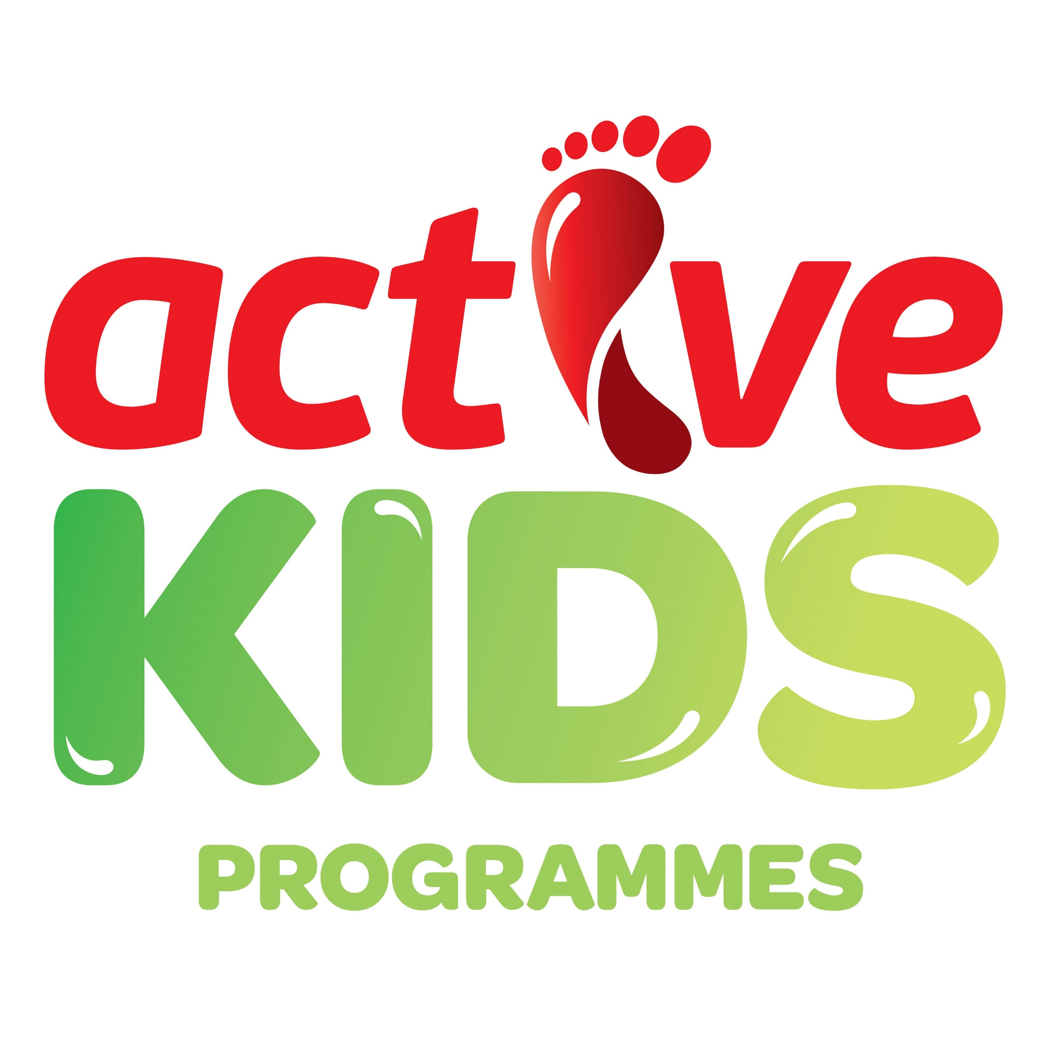
Active Kids Holiday Programmes
Registrations now open for January School Holidays– book online!
Week 1 – Mon 15th – Fri 19th *LINCOLN *WESTBURN *PAPANUI
Week 2 – Mon 22nd– Fri 26th *CHCH BOYS HIGH * ROLLESTON
- Join us for a week of action packed fun and adventure
- Delivered by enthusiastic, fully trained staff
- OSCAR approved; WINZ subsidies apply
- 8am starts and single day bookings available
P 03 373 50 60
E activekids@sportcanterbury.org.nz
www.sportcanterbury.org.nz

