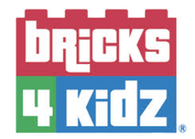

Kia ora!

The team at Bricks 4 Kidz are extremely excited to be hosting a FREE Family Fun Day event with you exclusively at Knights Stream School. Our teachers are looking forward to sharing their Lego knowledge and adventuring into a world of wonderful creations with you!

Join us on Saturday the 28th August between 1PM and 5PM at Knights Stream School where we will have a number of different things for you to enjoy and open you up to a new world of learning with Lego.

You can look forward to:
- A 40 minute Workshop demonstration
- Hands on Colour Kit Station
- Lego Creative Play Station

We incorporate Lego learning with the principle of science, technology, engineering, art and maths (STEAM). Wherever your interests are set, we have something for everyone!

To join our 40 minute workshop, head to the link below and secure your spot! The Colour Kit Station and Lego Creative Play Station do not require a booking, come along anytime you please and check out what we have to offer!

https://www.bricks4kidz.co.nz/christchurch-north-west/knights-stream-school-family-fun-day/

See you all soon as we begin our journey of becoming Lego Master Builders.
