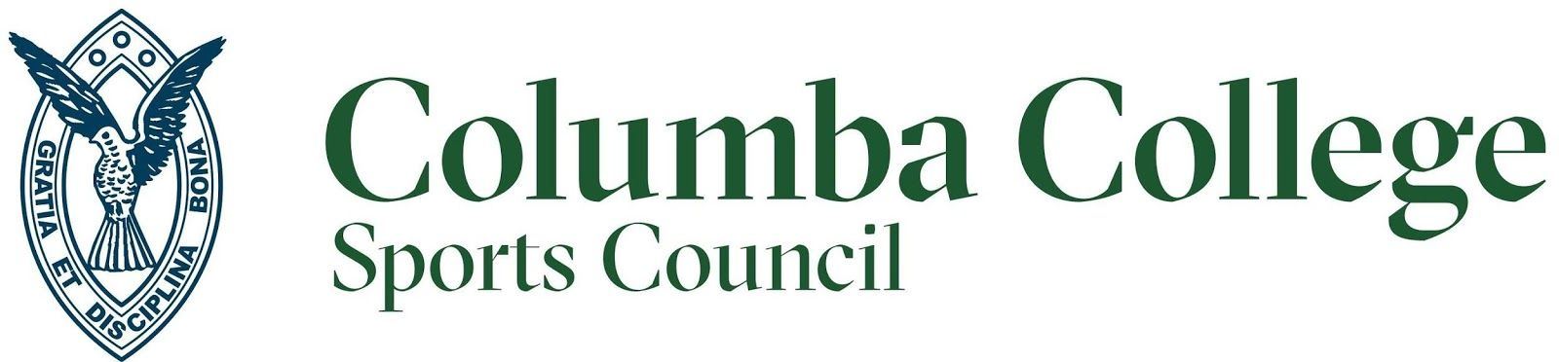

Dear Prospective Golf Day Participants
We are looking for teams to play in our annual Columba College Golf Tournament, and hope that you and your colleagues/friends will be keen to be involved in a fantastic day. Following the success of our golf tournament in 2020, we have confirmed a date with the St. Clair Golf Club for Friday 16th September, 2022. An ambrose golfing format will be followed, with registrations beginning at 10.00am on the day and a scheduled tee off time of 10.30am.
The Golf Tournament is a major fundraiser for the year, and money raised from this day enables the Sports Council to provide sporting opportunities for every student at Columba College. Whether it be competitive or social, an 85% participation rate in sport at our school means many students across a large number of sports will benefit directly and indirectly from the proceeds of this event. Our aim is to ensure we continue to recognise all sports across every level at the school and provide assurance that all students have access to the appropriate uniforms, equipment and resources needed to play the sport they love.
We are in the process of securing hole sponsorship, collecting an exciting range of prizes for our winners, and organising a number of fun challenges on the course for the day. Some of our challenges include ‘beat-the-pro’, longest drive, closest to the pin and an amazing hole in one reward!
We would love to see you and your team at our annual Golf Tournament. By entering a team of 4 players for $400 (+ GST), you will receive:
- Entry and green fees
- All day BBQ provided by two hospitality tents stationed on the course
- ‘Hospitality Drinks’ courtesy of Refreshment Carts
- A Meal in the St. Clair Clubrooms at the conclusion of play
- Incredible hole-in-one prize
- Opportunity to take part in various on-course fundraising activities
- Lots of raffle opportunities throughout the day and afterwards in the clubhouse
- An amazing assortment of auction items to bid for on the night
We are also seeking hole sponsors for all 18 holes ($400 + GST). You can opt for a combo deal whereby you receive team entry and hole sponsorship for a special rate of $600 + GST. In return for sponsoring a hole, you are provided with an excellent opportunity to advertise your business through:
- Signage rights at your designated hole
- Acknowledgement of your support at the event and your contribution to the overall sporting
programme and opportunities for Columba College students
For entry information and any queries, please contact:
- Dayna Turnbull (Director of Sport):
Email: dturnbull@columbacollege.school.nz
Phone: 027 3447904

- Gretchen Beardmore (Sports Administrator):
Email: gbeardmore@columbacollege.school.nz
Phone: 021 2594846
Payments can be deposited into Columba College’s Westpac account 03-0903-0607954-00 with the references Golf Tournament and the name of the contributor, please. It’s shaping up to be a great day and we would love for you to be involved in this important fundraiser event.
We look forward to hearing from you soon!
Kind Regards,
Columba College Sports Council

