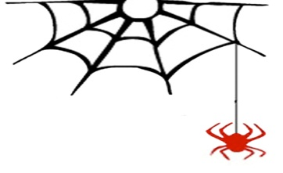
Beyond This Story – ‘Beyond the Stars’

Tauranga Writers’ 2015 NZ Intermediate School (free) annual writing competition

Conditions of Writing Competition

PLEASE READ ALL CONDITIONS OF ENTRY CAREFULLY.
ENTRIES WHICH DO NOT MEET ALL OF THE CONDITIONS WILL NOT BE ACCEPTED.

Create an original piece of writing (short story) using the following phrase as the theme or as a line anywhere in the piece of writing (but NOT as the title): ‘Beyond the Stars.’
- your piece of writing must be no more than 750 words
- your piece must be written with elements of science fiction, or fantasy

* Entry is Free and you may enter as many times as you like but all entries must be received by midnight Sunday 15th November 2015. No late entries will be considered.

To be eligible for this competition all participants MUST:
* be currently enrolled in year 7 or 8 (intermediate) at a New Zealand School or the NZ Correspondence School.
* produce an original piece of writing, which has not been published anywhere else.
* type using Arial font size 12 point.
* format the piece with 1.5 line spacing and paragraphs.
* write using English as the main language.
* use correct spelling, punctuation, and grammar.
* include their full name, school, year, the title of piece, and their HOME email at the top left hand corner of the piece of writing.
* submit the piece as a ‘doc’ or ‘docx’ file, with the file name being their own full name. (If submitting more than one piece, please use your full name and a unique number – 1, 2, etc. – to distinguish between your pieces.)
* send the file as an attachment to taurangawritersnz@gmail.com. Put your full name, name of school, and year level in the subject line of your email.

If you need more guidance please email taurangawritersnz@gmail.com

Judging
* All judges’ decisions are final.
* Winners will be notified by email.

Editing
* An anthology of the best writing will be published as both print and e-book versions, to be launched at a public event in March 2016. Entry into the competition is considered as permission from the author for their piece of writing to be included in this anthology. Copyright remains with the individual authors.
* Work selected for the anthology will be edited, in conjunction with students, prior to publication.
* All editors’ decisions are final.

Prizes
* Winning participants will receive:
- critical feedback (mentoring) by the judge of their section on a further piece of writing
- a selection of books from the Phantom Paragrapher (http://thephantomparagrapher.blogspot.co.nz/)
- a book token supplied by the Bookrapt (http://www.bookrapt.org.nz/).

