UCan SVA Leadership Course
By Hannah Ferris and Asha Biggs

We were lucky enough to participate in a 3-day leadership course with the University of Canterbury's Student Volunteer Army. This opportunity was over three weeks in which we learned several skills including teamwork, leadership, planning, and communication. We were able to work with around 6 other schools and each school selected 4-5 students to attend this, in which we planned and produced a volunteering activity with Cultivate Christchurch which is a social enterprise that combines productive urban farming, youth development, and community participation.
On the first day, we travelled to the University of Canterbury where we were able to get to know the 6 other schools. We were working with Rangi Ruru, St Margarets, Papanui High, Riccarton High, Cashmere High, and Rangiora High. We started by getting to know the Student volunteer army and what they do. We then got a tour of the centre of the university of canterbury in which we were able to experience and view the engineering block of the university and the science blocks. After we got a tour of the UC centre we got split into two groups in which we then spent some time playing a team leadership and team bonding game. We had two gumboots and we had to get the whole team across to the other side, just using the gumboots. This was great as we got to know the other people that we would be working with. We learned valuable skills in this game and it was fun getting to know each other experience. We then shared our ideas for next week's project planning. We planned how we would split up our jobs, who would be doing what and what our lunch options would be.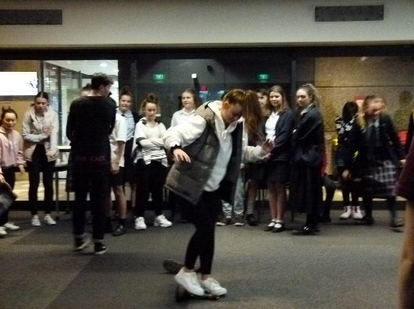

On Wednesday 7th August we travelled to 156 Peterborough Street in Christchurch Central City to visit and help volunteer at Cultivate Christchurch. This project involved various jobs including shoveling mulch, worm tending, composting and finally clearing out the overgrown weeded corner. We got the lucky job of digging out the overgrown weeds and mud. We then transferred it into another part of the site and raked it out, put cardboard over the top of it and then covered it with wood chips so that weeds couldn’t grow through and it was another space on site for it to be used for produce. This was great because we were all split up at the site and we were working with a whole new group of people. We all used skills like teamwork, communication and lots of hard work in order to make it work. We managed to finish our job perfectly on time for lunch which was great. At the start of the session, we also got a rundown of what they actually do at Cultivate Christchurch which is producing and selling organic fruit and vegetables and selling them locally. Another cool thing that Cultivate Christchurch does is they deliver their products to cafes and restaurants locally on bikes. The restaurants and cafes then pay them for not only producing and delivering those organic products but also they pay them to take their food scraps which then they use to feed the worms and make the compost so it all goes in a big circle. This day was probably our favourite day because we were busy bees and we had lots of fun. As we mentioned before, it was an extremely fun day and we were always busy. We also got to learn so many skills. Here are some photos from our day out. 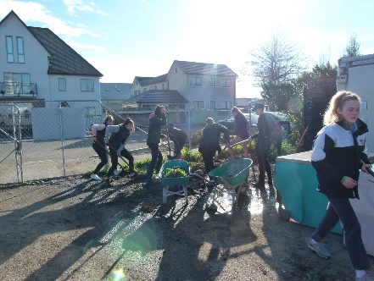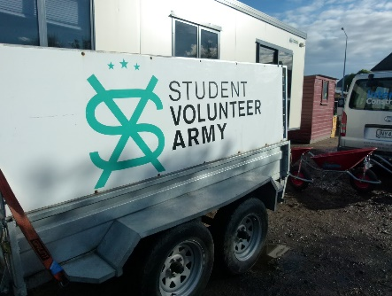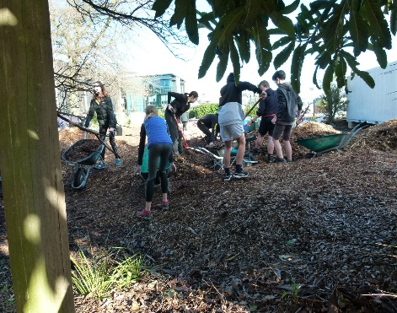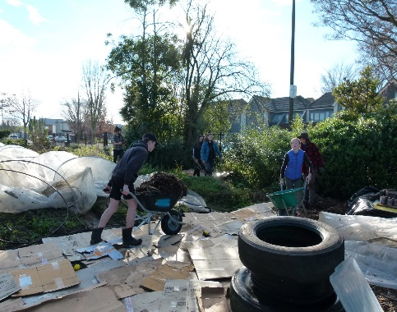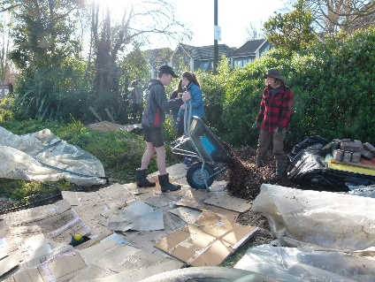
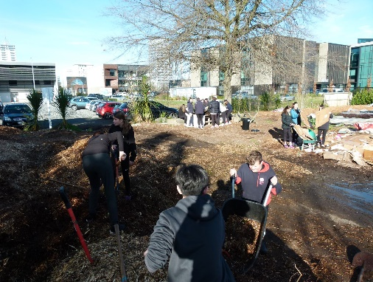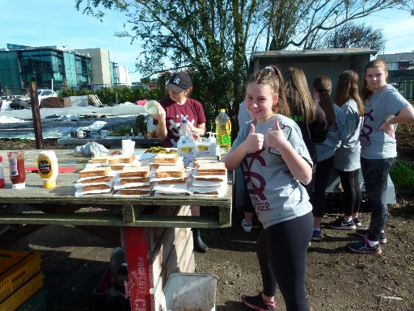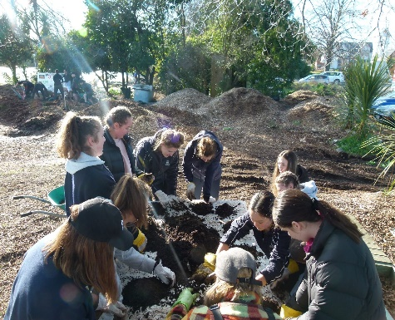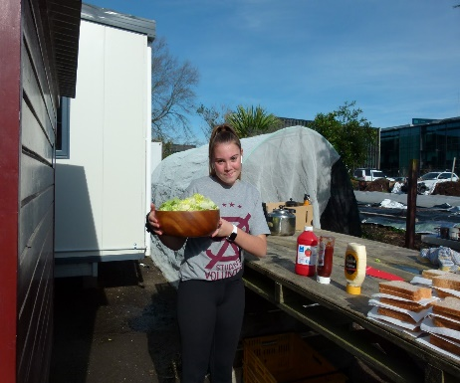
Our final day was a day full of reflections and planning for the future. We started by reflecting on our project day, we thought about what went well and what we would change next time. We got to do these activities in groups from different schools and it was great fun to connect up with other schools again. Our groups could think of many positives from the project day but not many negatives as we all had such a good busy day and we couldn't find anything we would change except for maybe doing a full day. After this, we worked in a new group and created a project which probably wouldn’t be realistic but it was so much fun because we were able to be creative. This was such a fun challenge and we didn’t work with just our school again. There were things like an underwater marine hospital, flying hospital, magnetic spacecraft and fairies, and dolphins who transported food to the homeless. Finally, we worked on what project we could actually do back here at school. We are now on our way to running events at primary schools which will be great fun and we can put our skills that we have learned into place.

We are very thankful for this experience and it was great because we got to learn so much and got to learn so many new skills. It was lots of fun and we would recommend it to anyone thinking of completing the UC Volunteer Army course next year.

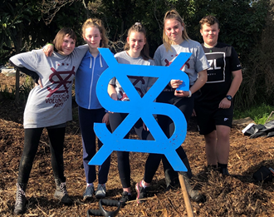
Our BHS Team - Jax Kinley Bianca Youl, Hannah Ferris, Asha Biggs & Jayden Upston

